**END OF TERM ONE EXAMINATION 2024 – EXTERNAL**

**CLASS: PRIMARY TWO**

**SUBJECT: MATHEMATICS**

**Name: ____________________________________________**

1. Add correctly:

9 + 5 = _____________________

1. **Name the set**



 ___________________________



1. 6 x 2 = **________________**
2. **Fill in the missing numbers.**

204, 205, 206, 207, _________

1. **Work out**

3 + 3 + 3 = ______________

1. **Write in words**

4 __________________________

1. **Complete correctly**

726 = ____________ hundreds _________ tens __________ one

1. What is the place value of 8 in 289?

**_________________________________________________________**

1. How many days are there in one week?

_________________________________________________________

1. Circle the bigger number

24 and 42

1. How many fingers are there on one hand?

**_________________________________________________________**

1. **Shade $\frac{2}{4}$**
2. **Tell the time**

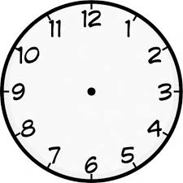

It is _________________ O’clock.

1. **Write in figures.**

nineteen: ________________________________

1. **Subtract 4 from 9**
2. **A _____________________ is a collection of well defined members.**
3. **What number is shown on the abacus?**

**T O**

1. 6 balls + 5 balls = ____________________________
2. **Work out**

$\frac{7}{9}$- $\frac{2}{9}$

1. **Add using the number line**

6 + 3 =

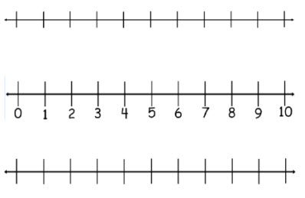

**SECTION B (60 MARKS)**

1. Work out these numbers.

a) H T O b) H T O

1. 2 4 4 2 3
2. 1 2 + 1 2 4
3. Name the shapes on Mr. Kasiru’s pick – up

A: __________________________

A B: __________________________

C: __________________________

B

1. **Match correctly.**

**Ø** Union set

U Intersection set

Ո Not equal sets

≠ Empty set

1. **Divide / share equally**

a) 9 ÷ 3 = b) 12 ÷ 4 =

c) 5 15

1. 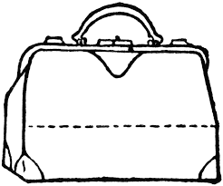Mummy went shopping on Saturday and bought the following items.

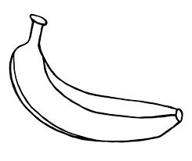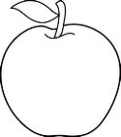apple a bag a banana

sh. 500 sh. 900 sh. 100

a) Name the most expensive item on the list.

_________________________________________________________

b) How many items did mummy buy?

_________________________________________________________

c) What is the cost of an apple and a banana altogether?

1. **Read and work out.**

a) Mary is 9 years. Sarah is 6 years old.

i) Who is older?

_____________________________________________________

ii) Who is younger?

______________________________________________________

iii) Find their total age

b) Tom has 12 books. Rose has 14 books. How many books do they have altogether?

c) Kato shared 14 pencils equally between 2 boys. How many pencils did each get?

1. **Fill in longer or shorter.**

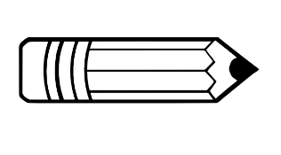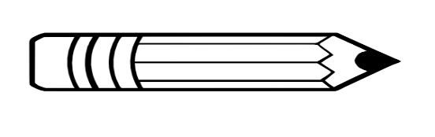A B

a) Pencil A is ________________ than pencil B.

b) Pencil B is _________________ than pencil A.

1. Study the graph below and answer the questions.

Eggs picked on Saturday.

|  |  |  |  |  |
| --- | --- | --- | --- | --- |
|  |  |  |  |  |
| Mike | Liz | Joy | Dan | Musa |

a) How many eggs did Musa pick?

_________________________________________________________

b) Who picked the least number of eggs?

_________________________________________________________

c) How many eggs did Liz and Mike pick altogether?

_________________________________________________________

1. Add the fractions.

a) $\frac{2}{4}$ + $\frac{1}{4}$ = b) $\frac{3}{8}$ + $\frac{1}{8}$ + $\frac{2}{8}$ =

1. Name the shaded fraction

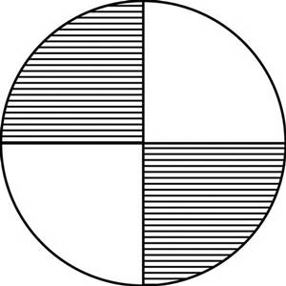

_____________ b)

|  |  |
| --- | --- |
|  |  |
|  |  |
|  |  |

_____________

1. Write 234 in expanded form.

***THE END***